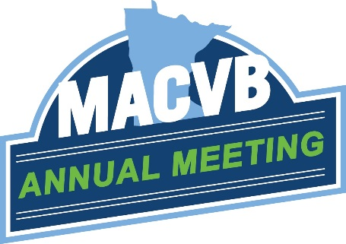
Committed to advocating and advancing Minnesota’s destination marketing industry.
AGENDA
AGENDA Tuesday, October 6, 2020 | 9:00 – 12:00 Noon

9:00 AM Conference Welcome
9:05-9:10 AM Sponsor Remarks

9:15-10:15 AM Opening Keynote by Adam Sacks, Tourism Economics
Preparing for the Recovery
Historic travel industry losses continue to mount. However, signs of recovery point to opportunity for destinations over the next 18 months. Adam Sacks will share Tourism Economics’ latest views on the economy, the current profile of travel, and expectations for how and when travel will fully recover.

10:15 AM Break

10:30-11:15 AM Program: “Travel, Tourism, Hospitality and Retail: The Next Normal”
Recent world events have impacted DMOs significantly, but our friends in the retail, hospitality and travel industries have been impacted as well. Learn how they and their members are responding and how industry changes will lead us to the next normal.
Panelists:
Liz Rammer, President/CEO; Hospitality Minnesota
Bruce Nustad, President; Minnesota Retailers Association
Brian Ryks, Executive Director/CEO; Metropolitan Airports Commission
Facilitator:
Bill Deef, Senior Vice President of Public Affairs; Meet Minneapolis

11:15-11:45 AM Program: DMOs and Public Policy
Are there policy solutions to help mitigate the economic impacts of the pandemic? MACVB lobbying team, Todd and Tony join us with to talk about the upcoming election and provide a legislative preview.
Speakers:
Todd Hill, Hill Capitol Strategies
Tony Kwilas, T.K. & Associates

11:45 AM Closing Remarks

12:00 Noon Adjourn

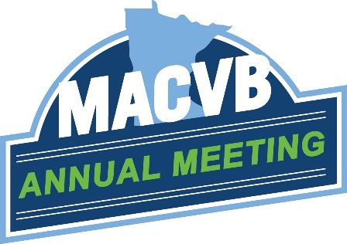
Committed to advocating and advancing Minnesota’s destination marketing industry.
AGENDA

AGENDA Wednesday, October 7, 2020 | 8:45 AM – 12:00 Noon

8:45 AM Conference Welcome

8:50-8:55 AM Sponsor Remarks

8:55 AM Program Intro

9:00-10:00- AM Opening Keynote by Bill Geist, DMOProz
The Future of Destination Marketing Organizations
There’s no going back…so what does the future hold for Destination Marketing Organizations? Author and consultant Bill Geist shares his views on how the fallout from the pandemic will change the way DMOs do what we do…and present opportunities to re-imagine our business model. From collaborative alliances to new revenue streams, Bill will challenge you to think differently about next steps.

10:00 AM Break

10:15-11:00 AM Program: Planning For an (Uncertain) Future
Long time DMO executive, Steve Markuson sets the stage and helps facilitate a panel of DMO executives to talk about budgeting, staff, contracts and planning for 2021.
Intro with Steve Markuson, Twin Cities Gateway
Panelists:
James Feist, Explore Alexandria
Bonnie Carlson, Bloomington CVB
Anna Tanski, Visit Duluth

11:00-11:15 AM Program: MACVB Annual Meeting

11:15-11:45 AM Closing Program: John Edman – Explore Minnesota Tourism

11:45 AM Closing Remarks/Thanks Sponsors/Adjourn

